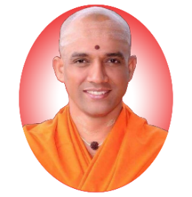**||JAI SRI GURUDEV ||**

**SRI ADICHUNCHANAGIRI TRUST (R.)**

**DEPARTMENT OF TECHNICAL EDUCATION**

**SJ BGS POLYTECHNIC**

**BG Nagar -571448, Nagamangala Taluk, Mandya District, Karnataka (India)**

 

**Topic: Cloud Computing**

**Submitted in Partial Fulfilment of Requirements for the award of 5th Semester**

**Diploma in**

**COMPUTER SCIENCE & ENGINEERING**

**Submitted by**

**MUTTURAJ U**

**Under the guidance of**

**Mr. HARSHA D P**

**Lecture of CS Department**

**SJ BGS POLYTECHNIC BG NAGAR -571448**

**DEPARTMENT OF COMPUTER SCIENCE & ENGINEERING**

**2025-2026**